**Course code: CSC-283**

**Lab Report: 06**

**Submitted To**

Tanzina Tasnim Bithi

Department of Computer, Science and Engineering

**Submitted By**

Name: Md.Pranto Ali

ID: 23303101

Program: BCSE

Section: A

Semester: Fall 2024

Submission date: Teacher signature

1. **Defining Derivd Class:**

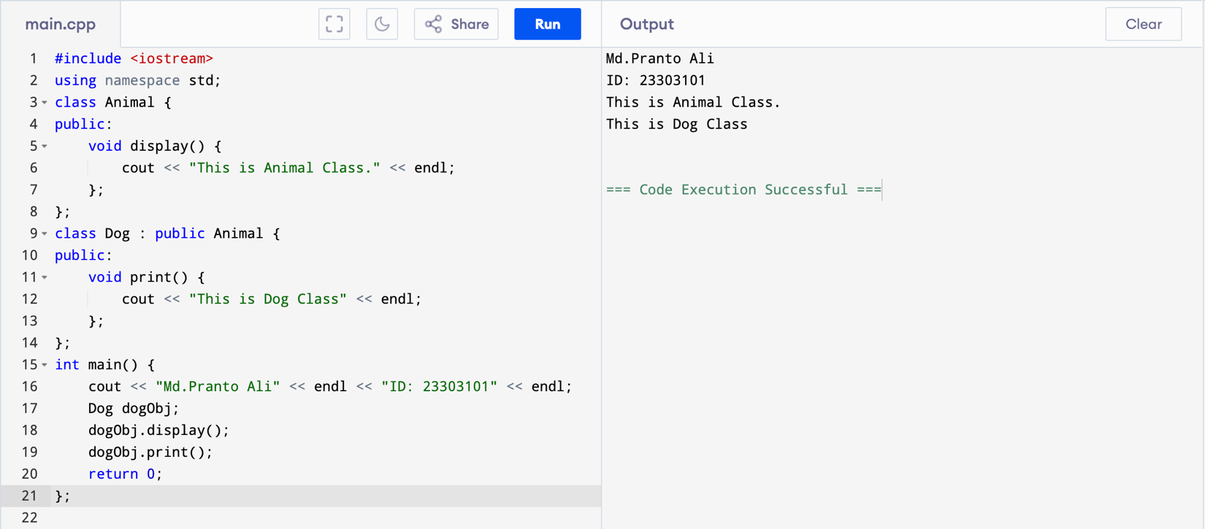

1. **Single Inheritance:**

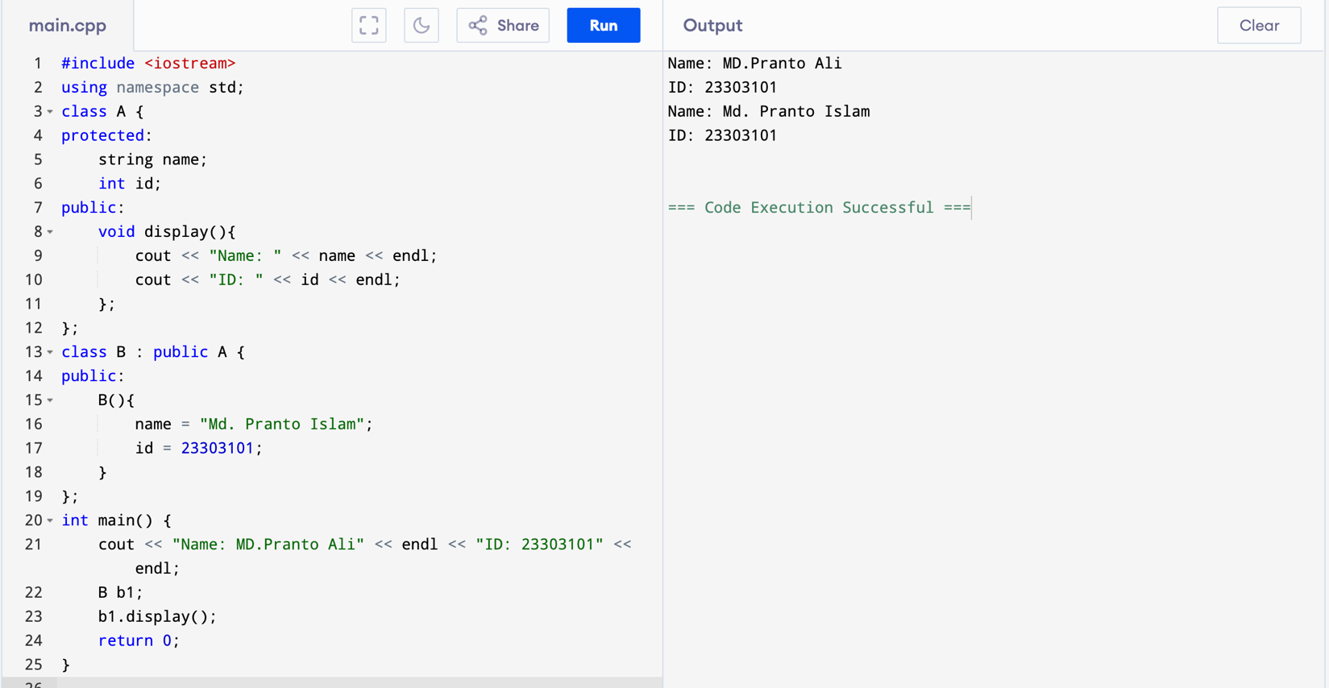

1. **Multilevel Inheritance:**

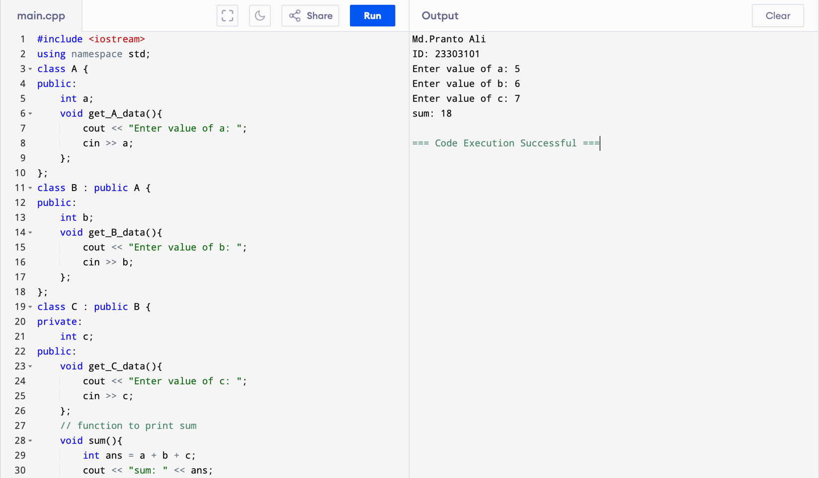

1. **Multiple Inheritance:**

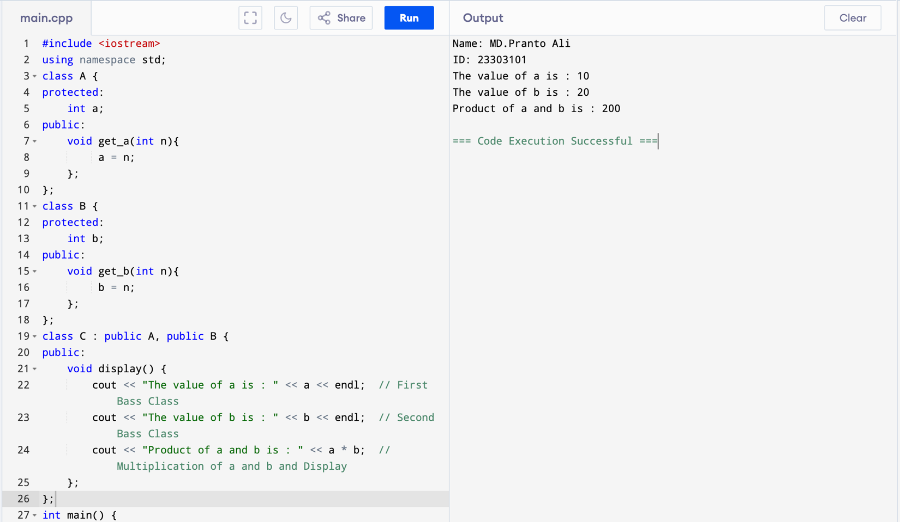

1. **Hierarchical Inheritance:**

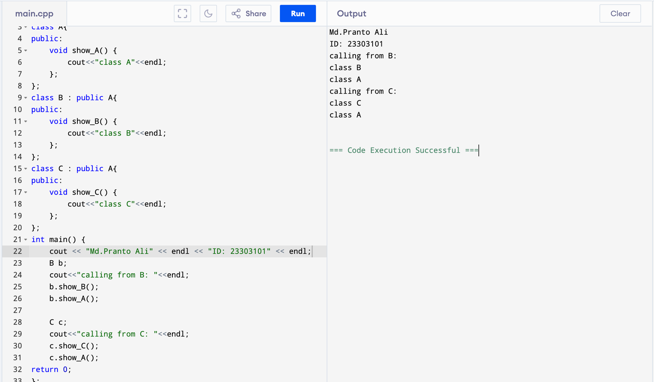

1. **Hybrid Inheritance**

